**GAME DESIGN DOCUMENT**

Dpn't deal with the devil

Cuphead

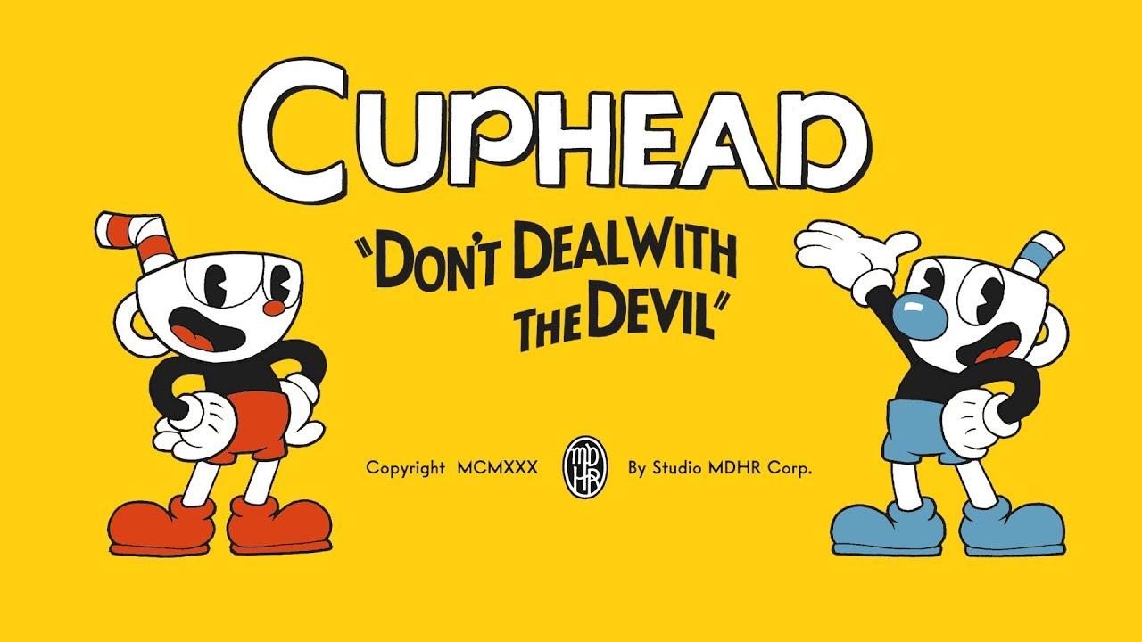

**Last Updated:**

Who knows

**Prepared By:**

Adrian Pavelić

**TABLE OF CONTENTS**

Game Analysis 3

Mission Statement 3

Genre 3

Platforms 3

Target Audience 3

Storyline & Characters 4

Gameplay 5

Overview of Gameplay 5

Player Experience 5

Gameplay Guidelines 5

Game Objectives & Rewards 5

Gameplay Mechanics 5

Level Design 6

Control Scheme 7

Game Aesthetics & User Interface 7

Schedule & Tasks 8

# Game Analysis

Cuphead is an old school like run and gun game but instead of mostly run and gun levels(getting to the end in one piece while shooting everything that is coming at you),here it is mostly boss fights with a couple of run and gun levels for variety.

The game takes it’s visual looks from the 1930’s era style cartoon, everything si hand

drawn . From the characthers to the bosses and their attacks.

# 

# Mission Statement

Cuphead is an run and gun shooter but with a loot of bosses. The art style is unique and it is very challenging.

# 

# Genre

Platformer

Run and Gun

Shoot’em up

# Platforms

Xbox One

Microsoft Windows

Mac OS

Nintendo switch(hopefully in the future)

# 

# Target Audience

The target audience for this game are people who appreciate a more harder and relentless experience, who accept that dying in three hits means game over. This will also be targeted towards people who are looking for more unique looking games, with it’s hand drawn look helping it stand out amongs the crowd.

# Storyline & Characters

Cuphead and his brother mugman are have lived in Inkwell isle without a care in the world. One day they have wandered off and ended up in the devil’s casino, where they gambled away. Once the devil came into the fray he offered them a deal, if they win the next roll of the dice they get his loot, but if they lose their souls belong to him. After losing the devil gave them a task, bring the souls of all of his debtors and they can keep their souls. Cuphead and Mugman ran away, now on a quest to save their souls against the devil.

Cuphead- the main character that the player controls. He

Mugman- playable as the second character. Only shows as a character if two players are playing.

Old kettle- the old wise kettle that watches over the cuphead brothers. Used as the intro tutorial

King dice- the sleazy right hand man to the devil with a head for a dice that runs the casino

And helps the devil get the souls he wants. Serves as the second to last boss before the devil himself.

Devil- the main antagonist of the game which starts the story and serves as the final boss of the game. Steals the souls of people he tricks and blackmails you for his own personal gain.

# Gameplay

## Overview of Gameplay

The gameplay will be in the typicila run and gun vein of press button to shoot.You can shoot in all 8 directions, you can change out your projectiles with which you shoot. You can always shoot with 2 different projectiles in a level. The projectiles vary from distance travvelled to the damage output. Also there are extra equips like an extra heart or an automatic first parry.Thirdly, there will be a special attack that after a certain amount of time will be available and deals massive damage. There is also a parry system, which allows for an extra element to the game. Each projectile that is pink allows you to parry it by double jumping, taking no damage, helping you jump further distances when parrying that projectile and filling your meter for your special attack.

## Player Experience

The game will be centerd around boss fights. Each level is a different boss fight, with 3

Phases, each phase having different attacks and making it more difficult for the

player. Ther is no health bar on the screen for the boss, instead when you die it

s shows you how close you have gotten to beating the boss adding to the tension of

the boss fight. The attacks vary in their patterns and you have to watch very closely

at the boss and when his attack is telegraphed because it only lasts 2 or 3 seconds

before he actually attacks.

## Gameplay Guidelines

The game will be in a cartoony style so it will be very tounge and cheek.While there are some dark elements to it like going in debt while gambling it will never lose focus on showing fun animations with expressive characters.

## Game Objectives & Rewards

|  |  |  |
| --- | --- | --- |
| Rewards | Penalties | Difficulty Levels |
| Beating bosses helps progress the story, plus you can find coins to use at a shop | If you die in a boss fight you will have to restart it from the beginning. | The same hard difficulty from beginning to end. |

## 

## Gameplay Mechanics

|  |  |
| --- | --- |
| **Character Attributes** |  |
| **Character** | **Movement Abilities / Actions Available** |
| Cuphead | Moves left or right, can duck, double jump and shoots in all eight directions. Also to avoid a close attack the player can dash away |
|  |  |
| **Game Modes** |  |
| There are two difficulty: normal and expert. | In normal difficulty the boss won’t have all thre phases of the fight, meaning it will also be shorter and less difficult but it won’t allow the player to progress in the story. The expert  Difficulty will be the full boss fight and the only way to complete the game. |
| **Scoring System** |  |
| **Points/Coins/Stars/Grades/Etc.** | **How it’s Awarded & Benefits** |
| There are grades at the end of each level. You can get goins in the run and gun levels. | There are up to 3 coins in each run and gun level, but there are only a couple of those throughout the entire game. The coins allow you to buy different power ups at the store or different projectiles to equip before you start a level. The grade at the end of each level is mostly associated with the time it required to beat the game. There are no extra benefits to this except the sense of accomplishment and maybe a different filter for the game. |

## 

## Level Design

**Boss fights**

There are a 5 boss fights in the first two worlds, seven in the third world and two at the final stage of the devil’s casino. Most boss fights start the same with you starting at the far left of their screen and they are at the far right throwing attacks at you. Some change things up with having you constlantly jump from platform to platform as the screen moves on it’s own. Out of all of those 4 are in a plane, switching the game up a little bit but the core gameplay is still the same.

**Run and gun**

There are 6 run and gun platforming levels. They are your typical affair with not so many complex platforms to worry about just a constant barrage of enemyes which is the real problem because of the limited amount of attacks you can take before you die. Funhouse Frazzle uses an anty gravity mechanic allowin you at certain points to walk on the ceiling upside down and while the level Perilious Piers has a platform at the end of the level where you have to stand on it while it moves and survive incoming attacks.

# Control Scheme

|  |  |
| --- | --- |
| **Button/ Touch Input** | **Action it Performs** |
| Keybord:  Right arrow  Left arrow  Up arrow  Down arrow  Z  X  Y  Tab  C  Left Shift | Move Right  Move Left  Move Up  Move Down  Jump  Shoot  Ex Shoot  Switch Weapons  Look  Dash |
| Controller:  Left Stick X  D-Pad Right  D-Pad Left  Left Stick Y  D-Pad Up  D-Pad Down  A  X  B  Y  Left Bumper  Right Bumper | Move Horizontal  Move Right  Move Left  Move Vertical  Move Up  Move Down  Jump  Shoot  Ex Shoot  Switch Weapons  Look  Dash |

# 

# Game Aesthetics & User Interface

The entire aesthetic is based on 1930’s cartoons. Each characters movement is over exaggerated and rubbery. The filter uses grained filter to get across the effect of watching an old cartoon on your old television. There are also extra filters that the player can unlock like the two colour filter (technycolor style) for getting A ranks in almost all of the boss fights and the black and white filter for getting the pacisifist rank in the run and gun levels, which is only possible if you don’t fire a single shot through the entire level (can only be done with the invisible dash power up)

The UI is almost non existent. The player must constantly procces a lot of visual information at any given time, making it such that UI on the screen will just get in the way. There is a HP counter in the bottom, and the special power meter in the form of poker cards.